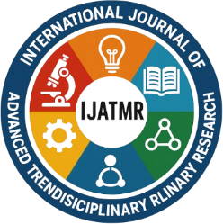 | International Journal of Advanced Trends in Multidisciplinary Research  (IJATMR)  Online Journal

COPYRIGHT TRANSFER FORM

Please complete and sign the form and send it with the final version of your manuscript. It is required to obtain written confirmation from authors in order to acquire copyrights for papers published in the journal.

Paper Id
Paper Title
Corresponding Author Details
Full Name
College/University
Postal Code |  | City
Country |  | Telephone/Mobile
Email

The undersigned hereby transfer any and all rights in and to the paper including without limitation all copyrights to the International Journal of Advanced Trends in Multidisciplinary Research (IJATMR). The undersigned hereby represents and warrants that the paper is original and that he/she is the author of the paper, except for material that is clearly identified as to its original source, with permission notices from the copyright owners where required. The undersigned represents that he/she has the power and authority to make and execute this assignment. We declare that:

- This paper has not been published in the same form in another journal.
- It will not be submitted anywhere else for publication prior to acceptance/rejection by this Journal.
- A copyright permission is obtained for materials published elsewhere and which require this permission for reproduction.

This agreement is to be signed by at least one of the authors who have obtained the assent of the co-author(s) where applicable.

Corresponding Author‘s Full Name and Signature

Date:……./……./…………

© IJATMR 2025

